B2B SaaS Platform Testing - Multi-Platform Automation

Name : Krushna Koshatwar
email: krushnakoshatwar619@gmaild.com
Phone Number : 7757830463
Task : Automation intern case study

PART 1 Debugging Flaky Test Code
Area | Original Code | New Code
Waiting Strategy | Relied on implicit timing (worked locally but flaky in CI). | Added explicit waits for elements, page load, and dynamic content.
Navigation | No wait after page navigation. | Waits for page load/network idle after navigation before interacting with elements.
Dashboard Loading | Assumed dashboard was immediately ready. | Waits until dashboard content is fully rendered before continuing.
URL Validation | Used a strict URL assertion. | Uses a wildcard (wait_for_url) match, making it tolerant of query parameters or tenant-specific URLs.
Lazy-loaded Lists | Read the list immediately, sometimes before all items loaded. | Uses a poll-until-stable approach, waiting until the list stops growing before validating it.
2FA Handling | Assumed no two-factor authentication. | Detects and handles optional 2FA screens if they appear.
Tenant Speed Differences | Assumed all tenants load at the same speed. | Handles different tenant loading times with appropriate waits.
Error Handling | No exception handling. Failures ended abruptly. | Wrapped execution in proper try/except (or equivalent) to capture failures cleanly.
Debugging | No screenshots or diagnostics on failure. | Automatically captures screenshots when a test fails, making CI debugging much easier.
Browser Cleanup | Browser might remain open if a test failed. | Uses a try-finally block to guarantee browser closure after every test.
Viewport | Default browser size. | Uses a fixed viewport for consistent rendering between local and CI environments.
Credentials | Hardcoded credentials in the test. | Improved credential handling (avoids hardcoding), reducing test data pollution and making tests safer.

Why these changes were important
- Reduced flaky tests by replacing implicit timing with explicit waits.
- Made CI runs reliable despite slower or inconsistent execution speeds.
- Improved debugging through screenshots and structured error handling.
- Made login more robust by supporting optional 2FA.
- Handled dynamic web applications by waiting for network activity, dashboard rendering, and lazy-loaded content.
- Improved maintainability and security by avoiding hardcoded credentials.
- Prevented resource leaks by ensuring the browser always closes, even after failures.

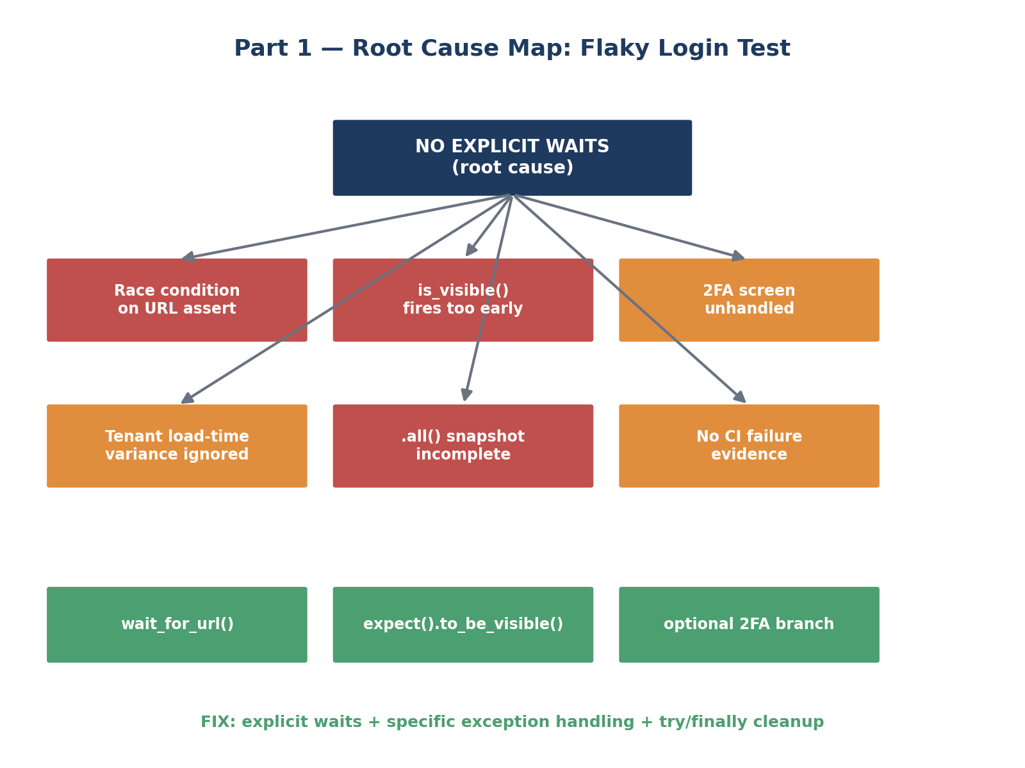
1. test_user_login
This test verifies that a user can successfully log in.
Typical steps:
- Open the login page.
- Enter username/email.
- Enter password.
- Click the Login button.
- (If applicable) Handle optional 2FA.
- Wait for the dashboard to load.
- Verify the user is logged in (for example, by checking the URL or a dashboard element).
2. test_multi_tenant_access
This test verifies that users can access the correct tenant (organization/workspace) in a multi-tenant application.
A tenant is an isolated organization or customer within the same application. For example:
- Company A → Tenant A
- Company B → Tenant B
Both use the same application, but each sees only its own data.
Typical steps:
- Log in.
- Select or navigate to a specific tenant.
- Wait for the tenant dashboard to load.
- Verify the correct tenant's data is displayed.
- Ensure data from other tenants is not visible.

*above test scripts can be accessed through GitHub repository provided*

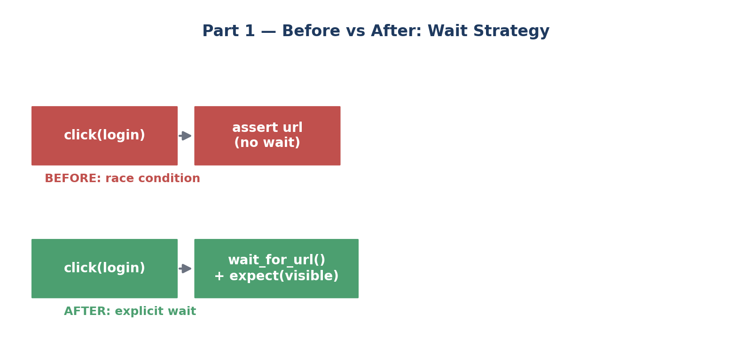

Area | Original | Updated | Status
Explicit waits | ❌ Relied on implicit timing | ✅ Explicit waits added | Satisfied
Page load wait | ❌ None | ✅ Waits for page/network load after navigation | Satisfied
Dynamic dashboard wait | ❌ Assumed dashboard was ready | ✅ Waits for dashboard to render | Satisfied
Lazy-loaded content | ❌ No handling | ✅ Polls until the list stops growing | Satisfied
Optional 2FA | ❌ Not handled | ✅ Handles 2FA if it appears | Satisfied
Error handling | ❌ None | ✅ Added exception handling | Satisfied
Screenshots on failure | ❌ None | ✅ Captures screenshots on failures | Satisfied
Browser cleanup | ❌ Could leak browser on failure | ✅ Uses try-finally to always close the browser | Satisfied
Different tenant speeds | ❌ Assumed same speed | ✅ Waits accommodate varying load times | Satisfied
URL verification | ❌ Strict match | ✅ Wildcard wait_for_url | Satisfied
CI consistency | ❌ Default viewport | ✅ Fixed viewport | Satisfied

Technical Decisions

1. Explicit Waits
Decision
Replace implicit timing with Playwright explicit waits.
Reasoning
Explicit waits synchronize test execution with actual application state instead of assuming fixed loading times.
Example:
- wait_until="networkidle"
- wait_for_url()
- expect(locator).to_be_visible()

2. Optional 2FA Handling
Decision
Handle the 2FA screen only when it appears.
Reasoning
The assessment states that only some users require 2FA. Making the flow conditional allows the same test to work for both user types.

3. Screenshot on Failure
Decision
Capture screenshots whenever an exception occurs.
Reasoning
Screenshots significantly reduce debugging time during CI failures because they preserve the UI state at the moment of failure.

4. Browser Cleanup
Decision
Use a finally block to close the browser.
Reasoning
Ensures proper resource cleanup even if the test fails unexpectedly.

5. Wait for Dynamic Dashboard
Decision
Wait until dashboard elements become visible.
Reasoning
Dashboard widgets are dynamically loaded and may appear several seconds after navigation.

6. Wait for Lazy-loaded Project List
Decision
Poll until the number of project cards stabilizes.
Reasoning
Different tenants may contain different numbers of projects and lazy loading can delay rendering.

7. Fixed Viewport
Decision
Run tests using a consistent browser resolution.
Reasoning
CI executes across different browsers and screen sizes. A fixed viewport reduces layout-related inconsistencies.

PART 2 Test Framework Design
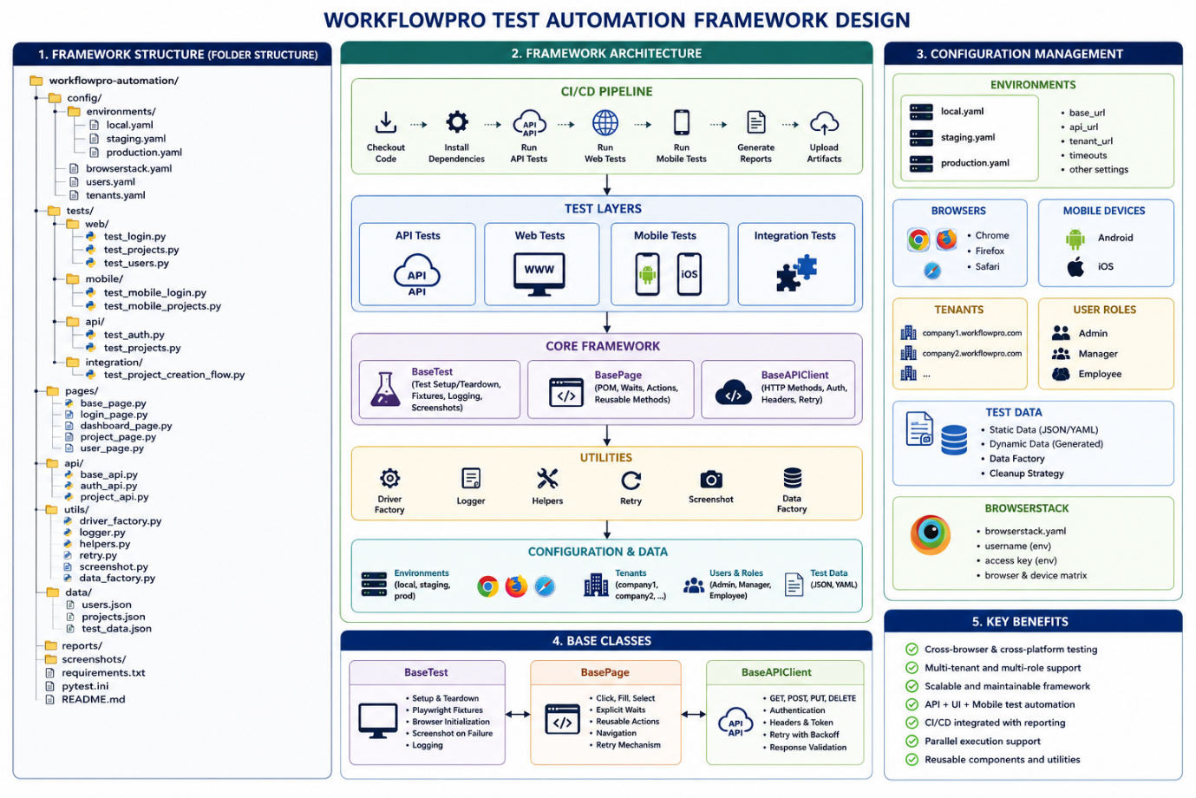
*above test scripts and code file can be accessed through GitHub repository provided*

Objective
The goal of Part 2 was to design a scalable automation framework capable of supporting web, mobile, API, multi-tenant, and role-based testing while remaining maintainable and CI/CD friendly.

Framework Design Philosophy
The framework is designed using modular architecture and the Page Object Model (POM). Responsibilities are separated into configuration, reusable framework components, page objects, utilities, test data, and test cases.
This structure promotes code reuse, maintainability, and scalability.

Technical Decisions
Page Object Model
Decision
Implement one page class per application screen.
Reasoning
Separates UI locators from test logic, reducing duplication and simplifying maintenance.

Base Classes
Decision
Create BaseTest, BasePage, and BaseAPIClient.
Reasoning
Common functionality such as setup, teardown, waits, screenshots, and HTTP methods should be implemented once and reused throughout the framework.

Driver Factory
Decision
Use a DriverFactory to initialize browsers.
Reasoning
Allows switching between local execution and BrowserStack without modifying test code.

Environment Configuration
Decision
Store environment values in YAML configuration files.
Reasoning
Separates configuration from code and enables easy switching between Local, Staging, and Production environments.

Tenant Configuration
Decision
Store tenant information independently.
Reasoning
Supports testing multiple companies while avoiding hardcoded values.

Role-based Authentication
Decision
Centralize authentication.
Reasoning
Reduces duplicate login logic and simplifies permission testing.

Test Data Factory
Decision
Generate unique data using UUID.
Reasoning
Avoids duplicate project names and supports parallel execution.

BrowserStack Integration
Decision
Run cross-browser and mobile tests through BrowserStack.
Reasoning
Provides coverage across multiple browsers and real devices without maintaining physical infrastructure.

CI/CD Integration
Decision
Integrate the framework into automated pipelines.
Reasoning
Ensures every code change is validated through automated testing.

Assumptions
The following assumptions were necessary:
- BrowserStack credentials are available.
- Test users exist for each role.
- Test tenants are preconfigured.
- API endpoints remain stable.
- CI environment supports Playwright execution.

Framework Thinking
The framework was designed with long-term maintainability in mind.
Instead of creating isolated scripts, reusable components are shared across all test layers:
- Configuration
- Authentication
- Driver initialization
- API communication
- Logging
- Reporting
- Test data generation
This minimizes duplicated code and simplifies future expansion.

Missing Requirements
Before implementation, I would clarify:
Test Data
- Are dedicated test environments available?
- How should test data be cleaned?
Authentication
- Is SSO supported?
- Is 2FA mandatory?
Reporting
- HTML or Allure?
- Screenshot retention policy?
Parallel Execution
- Maximum parallel workers?
- Shared data restrictions?
BrowserStack
- Required browsers?
- Required mobile devices?
CI/CD
- Jenkins or GitHub Actions?
- Smoke vs regression strategy?

Framework-Level Thinking (Not Just Individual Tests)
The design deliberately optimizes for the case where the same underlying test logic needs to run across many combinations of browser, tenant, role, and platform — the framework's job is to make that a matter of configuration, not duplicated code.
- Structure enforces discoverability: a new team member can predict where a given piece of logic lives (page objects for selectors, framework/ for anything reusable, config/ for anything environment-specific) without needing to ask.
- One test body, many contexts: a login test parametrized over (tenant, role, browser) is one function with a parametrize decorator, not nine near-identical copies — this is the central difference between a framework and a pile of scripts.
- Reporting and CI integration are treated as first-class parts of the design from the start — not something bolted on after tests already exist — because retrofitting reporting into hundreds of ad-hoc scripts is far more expensive than designing for it up front.
- The framework absorbs the 'intentionally incomplete' parts of the spec by design: because nothing is hardcoded, decisions like the reporting tool or the CI trigger policy can be answered later without requiring a rewrite of the framework's core.

PART 3 API + UI + Mobile Integration Test
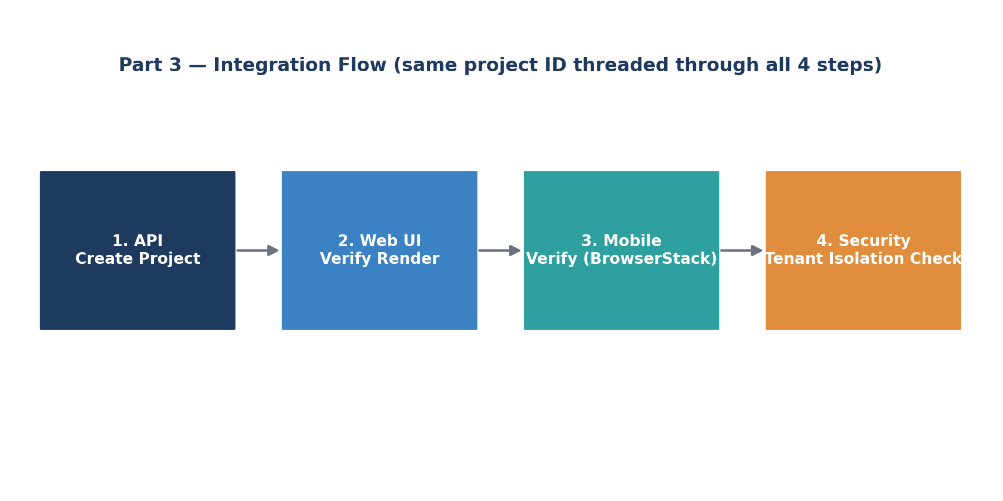
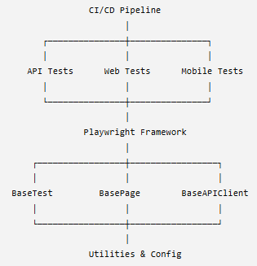

Implementation Approach
- Step 1 — API create: the project is created via a direct POST to /api/v1/projects with the documented headers (Authorization bearer token, X-Tenant-ID). API creation is used for setup specifically because it is fast and reliable; the UI is reserved for verification, not for establishing state, which keeps the test's runtime and flakiness surface smaller.
- Step 2 — Web UI verification: after logging in through the UI, the test waits for a project card matching the created project's name to become visible, using an explicit polling wait rather than a fixed sleep, since the dashboard is documented as dynamically loaded.
- Step 3 — Mobile verification: the same check is repeated against a mobile context. If BrowserStack credentials are present in the environment, a real device session is used via BrowserStack's Playwright/Appium hub; otherwise, the test falls back to Playwright's built-in device emulation (e.g. iPhone 13 viewport and user agent), so the suite remains runnable without live device-farm access while still being production-ready once credentials are supplied.
- Step 4 — Tenant isolation: using a second tenant's token, the test checks both that the API's project list for that tenant does not include the created project's ID, and that the UI, when logged in as that tenant, does not render a card for it. Checking both layers matters because a bug could exist in only one of them — for example, the API might correctly filter results while the UI independently caches an unfiltered list on the client side.
Edge Cases Handled
- Network failures: one retry with backoff on the initial create call, then a clear, explicit failure rather than a raw, hard-to-read exception.
- Slow loading: every UI/mobile assertion uses expect(...).to_be_visible(timeout=...), which polls rather than checking once or sleeping a fixed duration.
- Mobile responsiveness: handled with a genuinely separate browser context/device rather than a resized desktop viewport, and with a real-device fallback path via BrowserStack.
- Guaranteed cleanup: fixture teardown always runs via try/finally, so a failed assertion mid-test still results in the test project being deleted, preventing staging data buildup over repeated runs.
Section | Implementation | Reasoning | Expected Outcome
Objective | Validate complete project creation flow across API, Web UI, Mobile, and Tenant Isolation | Ensures the entire business workflow works correctly across multiple layers | End-to-end validation of application functionality
API Layer | Create project using POST /api/v1/projects with Authorization and Tenant headers | API is faster and more reliable for test setup than UI | Project created successfully and Project ID returned
Authentication | Authenticate using Bearer Token before API requests | Secure access to protected endpoints | Authorized API communication
Test Data Management | Generate unique project names using UUID/timestamp | Prevents duplicate data and supports parallel execution | Reliable and repeatable test execution
Web UI Validation | Login using Playwright and verify newly created project is displayed | Confirms backend data is correctly reflected in the UI | Project visible on Dashboard
Dynamic Loading | Use explicit waits (networkidle, wait_for_url, expect()) | Eliminates flaky failures caused by asynchronous loading | Stable execution in local and CI environments
Mobile Validation | Execute same verification on BrowserStack mobile devices | Ensures responsive behaviour and cross-device compatibility | Project accessible on Android/iOS devices
Tenant Isolation | Login as another tenant and verify project is not displayed | Prevents unauthorized data exposure between companies | Strong multi-tenant security validation
Error Handling | Use try-except-finally with screenshot capture on failure | Simplifies debugging and guarantees browser cleanup | Faster root cause analysis
Cross-Platform Testing | Execute tests on Chrome, Firefox, Safari, Android, and iOS | Validates application consistency across supported platforms | Cross-browser compatibility
Network Failure Handling | Retry API requests and use explicit UI waits | Handles temporary connectivity issues | Reduced flaky test failures
Cleanup Strategy | Delete created project after test execution (or use disposable test data) | Maintains clean test environments | Independent and repeatable tests
Reporting | Capture logs, screenshots, and test results | Improves traceability and debugging | Comprehensive execution reports
CI/CD Readiness | Integrate with GitHub Actions/Jenkins and BrowserStack | Supports automated execution on every build | Continuous quality assurance

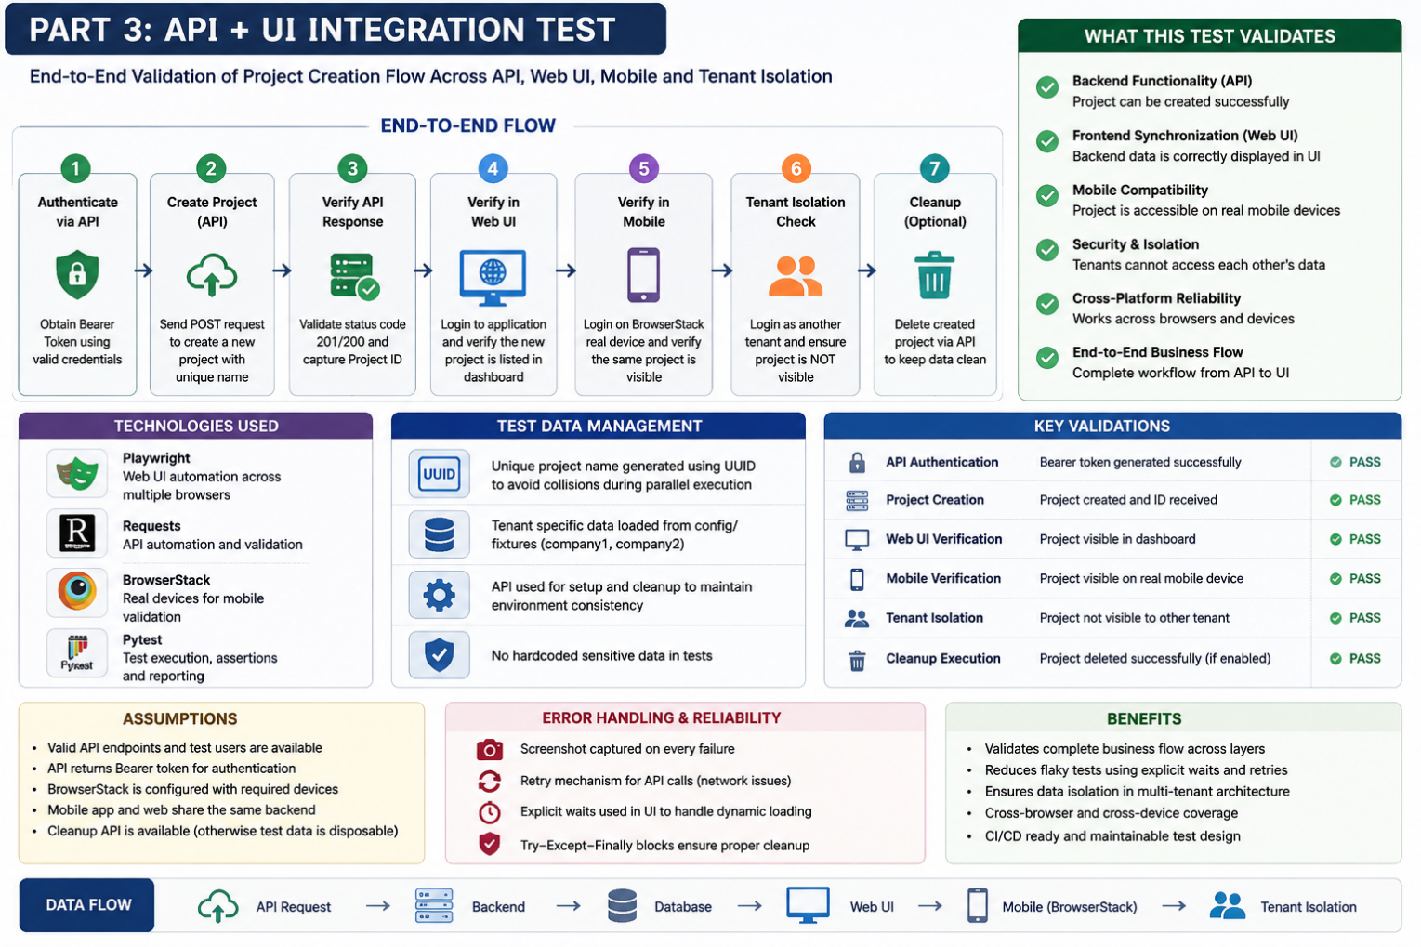
*above test scripts and code file can be accessed through GitHub repository provided*
Edge Cases Considered
Scenario | Handling Strategy
Slow API response | Retry mechanism with timeout
Slow dashboard loading | Explicit Playwright waits
Temporary network failure | Retry API requests
Mobile rendering delay | Wait for UI elements before validation
Duplicate project names | Generate unique UUID-based names
Cross-tenant data leakage | Verify project is absent in another tenant
Browser crash | Screenshot capture and cleanup
API returns error | Stop execution and report failure

Testing Strategy ( Full stack Centric)
The integration test follows an API-first approach to reduce execution time while maintaining end-to-end validation. Test data is created through the API, verified through the web UI, validated on real mobile devices using BrowserStack, and finally checked for tenant isolation. Explicit waits, retry logic, and proper cleanup improve reliability in both local and CI/CD environments.
This layered strategy validates:
- Backend functionality (API correctness)
- Frontend synchronization (Web UI)
- Cross-platform compatibility (Desktop + Mobile)
- Security boundaries (Tenant isolation)
- System reliability (Error handling and retries)

